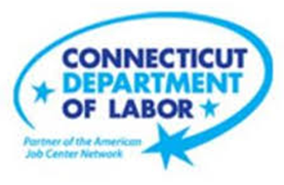

**NEW WEEKLY JOB POSTINGS FROM   
HELP WANTED ONLINE  
Office of Research**

**Week Ending June 11thth, 2022: Total New Ads Rebound to Near-Peak Levels**WETHERSFIELD, June 17th, 2022 – During the week ending June 11th, there were 11,924 new postings, up 5,077 new ads or +74% over the week. The most recent weekly new ad total is a rebound from the prior week, which was the lowest level since mid-April. This one-week increase shifted total new ads to the third highest level of the 2022 and 928 ads below the early May series high of 12,852 new ads. Three Industries comprised a combined 39 percent of this overall increase; Health Care & Social Assistance, Finance & Insurance, and Manufacturing. Employers with the largest over-the-week increase include Capital One (+242 new ads) and Amazon (+148 new ads). Occupations with the largest ad increase over the week include Driver/Sales Workers (+214 new ads), Wholesale & Manufacturing Sales Reps (+132 new ads), and Retail Salespersons (+128 new ads). This one week increase of just over five thousand job ads is the largest shown in the graph below. The graph also shows that the swings experienced in Connecticut echo large shifts at the US level.   
  
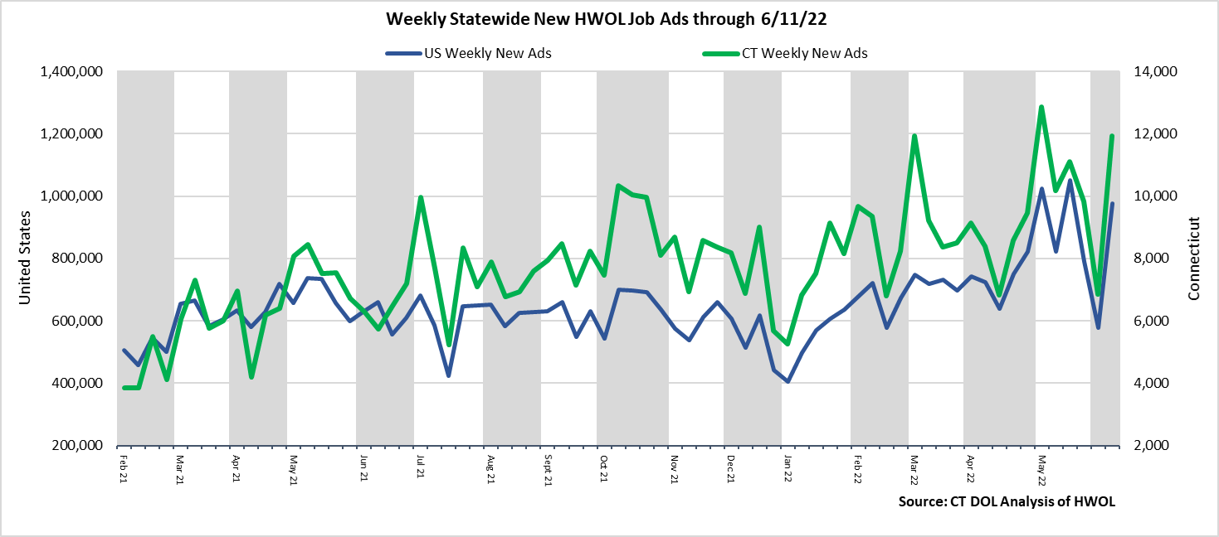  
**Industries** with the most new postings include Health Care & Social Assistance, Finance & Insurance, and Manufacturing.

**Occupations** with the most new postings include Registered Nurses, Retail Salespersons, Wholesale & Manufacturing Sales Representatives.

**Employers** with the most new postings include Capital One, Amazon, and Hartford Healthcare.

**The three industries with the most new job postings were:**

* **Health Care & Social Assistance** (2,218 new postings, +66% over the week)
* **Finance And Insurance** (1,311 new postings, +90% over the week)
* **Manufacturing** (1,075 new postings, +79%% over the week)

   
 During the week ending June 11th, the total ad increase of 5,077 or +74% is the net result of over the week increases in every industry and follows a total drop of 2,992 during the week ending June 4th. Every industry had over the week new ad increases of 32% or more. Some of the largest percent increases among industries with large total counts include Educational Services (+194% or +343 new ads), Finance & Insurance (+90% or +620 new ads), and Manufacturing (+79% or +475 new ads). Over four weeks, 16 of 21 industries increased and 5 decreased. The largest four week increases occurred in Finance & Insurance (+298 new ads), Manufacturing (+281 new ads), and Health Care & Social Assistance (+280 new ads). The five declining industries fell by a combined 465 new ads over four weeks, most of that drop occurred in Transportation & Warehousing (-320 new ads).   
  
For more information on total job ads by industry for Connecticut and its labor market areas, see the monthly report available here: <https://www1.ctdol.state.ct.us/lmi/hwol.asp>

**New Job Postings by Occupation** 

**The occupations with the most new postings were:**

* Registered Nurses (484 new postings, +23% over the week)
* Retail Salespersons (295 new postings, +77% over the week)
* Wholesale & Manufacturing Sales Representatives (286 new ads, +86% over the week)

**Employers with the Most New Job Postings**

Employers with the most new job postings during the week were mostly in Health Care, Finance & Insurance, and Business Services. The 25 employers shown above account for 18 percent of all new ads. 23 of 25 employers in the top 25 had over the week increases, one was unchanged, and one declined. Over four weeks, 18 employers in the top 25 had increases and 7 had decreases. The largest of each over four weeks were Amazon (+219 new ads) and PricewaterhouseCoopers (-269 new ads).   
  
**What is HWOL?**The **Conference Board Help Wanted Online**® Data Series (HWOL) measures the number of new, first-time Online job postings and jobs reposted from the previous month for over 16,000 Internet job boards, corporate boards and smaller job sites that serve niche markets and smaller geographic areas. To view more HWOL data, go to: <https://www1.ctdol.state.ct.us/lmi/hwol.asp>